Implementation Proposal for



**VES Robotics Process Automation.**

**Presented by:**



**Tecnics Consulting Inc.**

5177 Richmond Ave, Ste 570  
Houston TX 77056

Sales & Recruiting: 281-822-7900

[www.tecnics.com](http://www.tecnics.com)

**TABLE OF CONTENT**

Executive Summary 3

Why Tecnics 3

Project Overview 3

*Introduction to VES Project* 3

Objective 4

*Project Objective* 4

High level Current Process Map 4

*Project Understanding* 4

1.1 EMS Application: 5

1.2 VA Environment: 5

1.3 Local environment 5

Project Architecture 6

*High level Architecture* 6

Proposed Process Work Flow 7

*Manage of Medical Records - Workflow* 7

Business Exception handling 8

Reporting 9

Implementation Hours 10

*High level Estimation* 10

Assumptions 10

*Baseline Assumptions* 10

Out of Scope 11

*Out of Scope* 11

# **Executive Summary**

This proposal Document outlines the business process chosen for automation using UiPath Robotic Process Automation (RPA) technology.

# **Why Tecnics**

Tecnics Consulting Inc. established in 1998, is a technical consulting company committed to enhancing the competence and competitiveness of its clients by helping them succeed through collaboration and the power of information technology.

Tecnics US Consulting headquarters is located in Houston, TX, Tecnics Middle East Consulting headquarters is located in Dubai, UAE, and Tecnics Technical Development Center of Excellence is located in Hyderabad, India.

Using a blend of onshore and offshore resources we have been able to cut IT costs for companies while providing high quality work with excellent customer service. Driven by the credo that solutions are effective only when organizational needs are accurately ascertained and aptly addressed, Tecnics looks upon itself as an integral part of its client's organizations. Tecnics approaches development and maintenance through simplified access to project domains. We provide 24/7/365 support channels to our global customer base.

# **Project Overview**

## *Introduction to VES Project*

VES is a Veteran owned service company, full time Veterans Liaison Team, led by a disabled Veteran of two wars, personally responds to all Veteran feedback requests and phone calls and communicates regularly with Veteran’s Service Organizations on both the state and federal level.

They help the veterans in VA (Veteran Affairs) disability claims process. In order to effectively process the claims, they will be using different type of systems which will store the information of Veterans medical records and other personal information.

# **Objective**

## *Project Objective*

VES is having VBMS website which is storing the medical records of Veterans which was maintain by the operators .Operators have to manually download these records from VBMS and maintain it in EMS application to process the claims.

The business objectives and benefits expected by the Business Process Owner after automation of the selected business process are:

* Automate the process of downloading the files (pdfs) from VA Server to VES Server.
* Merging the PDFs into single PDF file.
* *Reduce processing time per item by 80 %*
* *Better Monitoring of the overall activity by using the logs provided by the robots*

# **High level Current Process Map**

## *Project Understanding*

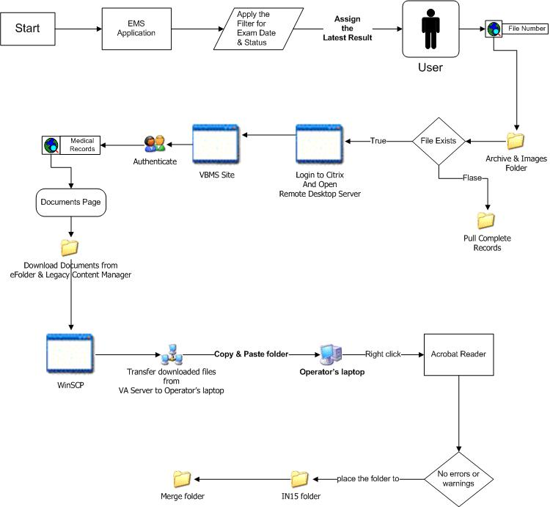

Each Operator logs into VES system and VA server using smart card and a pin.

## EMS Application:

1. From Operator’s laptop, open EMS application
2. Apply the filters for Exam Date and Status (Pending)
3. Open the latest result, and assign it to operator so that no one else will work on the case
4. Search for the File # in Archive Folder and Images Folder on the shared drive. If the file exists then Operator have to pull patient records from vbms site after the last processing date. If not, pull complete records

## VA Environment:

1. Login to Citrix environment
2. Open Remote Desktop Server
3. Open Internet Explorer and go to vbms website
4. Authenticate with the user name, password and pin
5. Search for medical record using File #. Verify that the name and DOB match with the information from EMS application
6. Go to Documents
7. Manually download documents from 2 tabs – eFolder and Legacy Content Manager into a folder
8. Rename the folder with File # and Operators first name initials and last name
9. Open WinSCP and connect to Operator’s laptop
10. Transfer downloaded files from VA Server to Operator’s laptop

## Local environment

1. Copy and paste the folder from WinSCP folder to local folder in Operator’s laptop. Placing the folder in IN15 to Merge.
2. Right click on the folder and click on combine files using Acrobat Reader. If there are no errors or warnings, place the folder in IN15 folder. Every 15 min, a program runs on this folder to merge the pdf files to one pdf file. This merged file is placed in Merge folder.
3. Once the file is in Merge folder, copy the file to Archive folder and update the comment field in EMS application with the number of pages in merged PDF file.

# **Project Architecture**

## *High level Architecture*

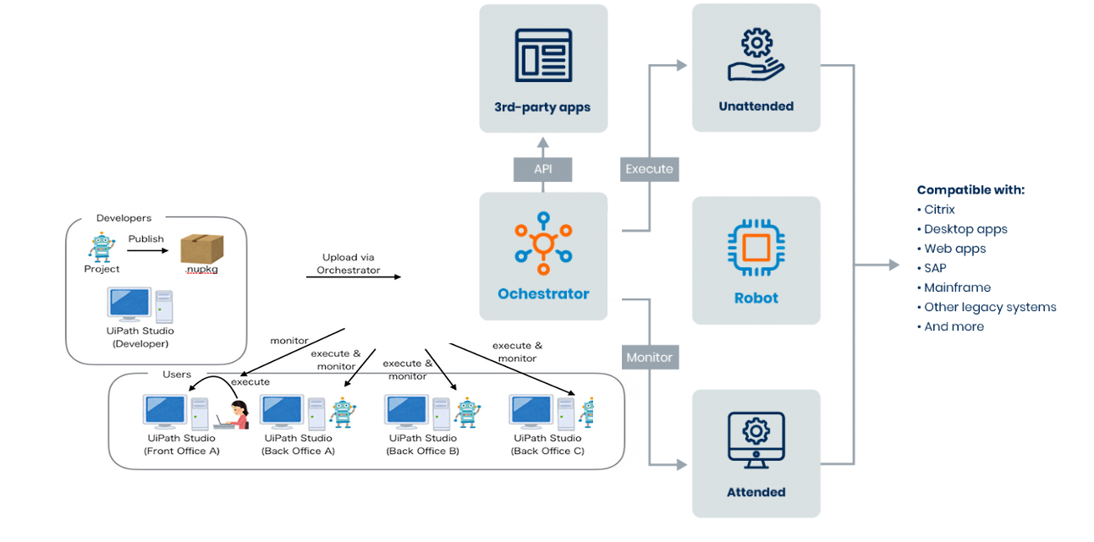

# **Proposed Process Work Flow**

## *Manage of Medical Records - Workflow*



1. BOT will run on each of the operator’s laptop
2. Operator will manually login to citrix environment
3. VES will provide a text file everyday which contains the list of all the veterans details whose medical records have to be downloaded
4. File will be placed in VA Citrix environment. It will be in the format – VBMSExport_Date_FileNumber_OperatorFirstName_OperatorLastName
5. Based on the operator who is logged into the system, the bot should process the file
6. VBMS login details will be maintained in orchestrator - static username, static pin, static station id, and the password changes every 45 days. Password will be updated in Orchestrator by the operators every 45 days
7. Using the credentials, bot will login to VBMS website, search for File #
8. Go to Documents tab, eFolder, download the files based on document type and subject. VES will provide Tecnics with the list of document types with the subject, which has to be downloaded
9. Go to Documents tab, Legacy content manager, download the files based on document type and subject. VES will provide Tecnics with the list of document types with the subject, which has to be downloaded. *Note: Only 5 files can be selected at a time. When clicked on download, each of the file will be opened. Bot has to rename the file and save it. Files can be saved with any name. Ex: 1, 2, 3, etc.*
10. Rename the folder to “FileNumber Operator_Initials Last_Name”
11. Upload the folder to VES Server (Operators laptop) using WinSCP
12. Copy from FTP to local folder in Operators laptop
13. Combine files and check for errors: Right click on folder, click on combine with acrobat reader, and verify that there are no errors. Errors can be related to:
    1. Signatures: Click on Combine Files
    2. Password Protection: Click on combine files. When the password prompt appears, enter the possible passwords (Will be maintained in a file in Orchestrator). If all the provided passwords don’t work, place the folder in Errors folder and proceed with next record from the text file
    3. Any other error: Open the PDF, click on lock icon, print the file to image. Optimize the file and replace the file in the folder. Try to combine the files again. If unsuccessful, place the folder in Errors folder and proceed with next record from the text file
14. If Combine Files is successful, delete the individual files from Operators machine
15. Place merged file in Archive Backup folder, and delete the file from Operators machine
16. Report and Email Notification:
    1. A report should be created with 3 tabs – Success, Failure and Summary. On a high level, the report should have following fields:
       * File number
       * Number of pages in merged file
       * Status
       * Error message
    2. This report should be emailed to the users at the end of the day

# **Business Exception handling**

Currently we are assuming that we do not have any Business Exception Validations.

## 

The Business Process Owner and Business Analysts are expected to document below all the business exceptions identified in the automation process. These can be classified as:

|  |  |
| --- | --- |
| Known | Unknown |
| Previously encountered. A scenario is defined with clear actions and workarounds for each case. | New situation never encountered before. It can be caused by external factors. Cannot be predicted with precision, however if it occurs, it must be communicated to an authorized person for evaluation. |

#### Known Exceptions

The table below reflects all the business process exceptions captured during the process evaluation and documentation. These are **known exceptions,** met in practice before. For each of these exceptions, define a corresponding expected action that the robot should complete if it encounters the exception.

|  |  |  |  |  |
| --- | --- | --- | --- | --- |
| BE # | Exception name | Step | Parameters | Action to be taken |
| **1** | Hash ID <> 40 characters | n/a | Hash ID | Send email with to __________________  “Hash ID <> 40 characters”  Go the next transaction |

#### Unknown Exceptions

For all the other **unanticipated or unknown business (process) exceptions**, the robot should:

Send an email notification at ____________ including error message Information.

# **Reporting**

## 

|  |  |  |  |  |
| --- | --- | --- | --- | --- |
| # | Report type | Update frequency | Details | Monitoring Tool to visualize the data |
| ***1*** | Process logs | Daily | How many times was this process run since the beginning of the month and what was the average run duration? | Csv File Posted daily on Provided Location |
| ***3*** | Transaction logs | Daily | How many transactions were run by this process since the beginning of the month and what was the average transaction duration? | Csv File Posted daily on Provided Location |
| ***4*** | Error logs | Daily | Average number of errors by type per day | Csv File Posted daily on Provided Location |
| ***5*** | Error logs | Daily | All errors per month grouped by type | Csv file posted daily on drive |

# **Implementation Hours**

## *High level Estimation*

|  |  |  |
| --- | --- | --- |
| **Project Phase** | **Responsibility** | **Man Hours** |
| Requirement Gathering | Tecnics & Client | 30 |
| Environment Setup & Configuration | Tecnics & Client | 40 |
| **Implementation(Dev)** | **Tecnics** | **100** |
| **Testing & Bug fixing** | **Tecnics** | **50** |
| User Acceptance Testing | Tecnics | 50 |
| Project Management & Documentation | Tecnics | 50 |
| Go Live | Tecnics & Client | 40 |
|  | **Total Hours** | **360** |

# **Assumptions**

## *Baseline Assumptions*

* The execution of the project will be by mix of onsite and offsite resources.
* The execution of the project will be delivered as per product out of box features.
* VES will provide system experts and business analysts necessary to gather the data and to develop an effective roadmap.
* VES will provide all necessary technical resources to help provide an understanding of the current environment.
* VES will provide dedicated space and facilities (e.g., desks, phones, development PC / Laptop, Internet access, LAN access, laser printers, analog lines and fax) for the project consultants.
* VES will appoint their own Project Manager who will coordinate and provide customer resources as required for the engagement.
* The UAT (including creation of test data and test scripts) will be carried out by VES and will be based on mutually agreed upon timelines, approved SRS and acceptance criteria.
* VES will give a sign-off based on this on completion of the UAT.
* It is assumed that relevant users will be available for testing. Any additional effort required for UAT support caused by either lack of resource availability or delay in completion of activities, for which customer is responsible, will be considered as additional work.
* Services are estimated to begin on mutual agreed dates.
* The language of engagement and deliverables will be in English.
* Assuming there will be no business validations , if any new business validations needs to implement then have to estimate the hours

# **Out of Scope**

## *Out of Scope*

* Changes required in existing backend applications for integration
* Upgrade or degrade of existing application for integration
* SSO with other parallel systems
* Data migration or data dumping using any for file formats
* Overwriting existing system workflow
* Classification of Data and various forms of data
* Analytical related integrations